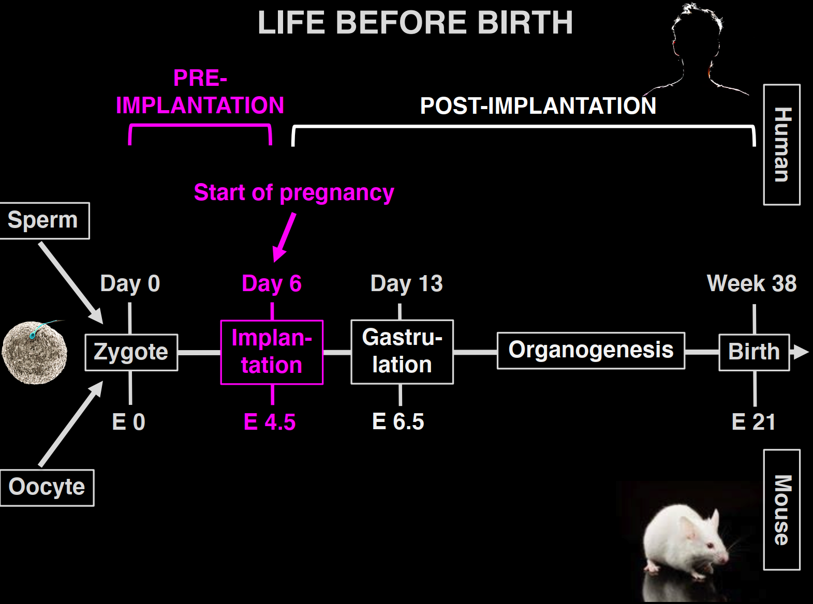

Markers of pregnancy: after implantation of zygote

Implantation: implant to uteri

Inner cell: pluripotent cell mass -> give rise to entire embryo proper

Same potency: pre-implantation embryos and humanmade embryos

Centrosome produce microtubule microfilament intermediate fiber to control the movement of organelle

5 stages pre-implantation:

1: cell decision: no centrosome, microtubule bridge take its place

2: polarization and compaction(8 cells): Cell polarity is established through sorting of plasma membrane proteins to apical and basolateral surfaces

Actin-rich filopodia are pulling on neighbor cells to trigger cell compaction

3: cell internalization(16 cells):inner cell and outer cell(protein control)

4: embryo sealing(16-32 cells): zip cells to protect inner cells and

5:blastocyst formation(100+):

water and sodium pumped into embryo

Meaning of understanding early embryogenesis: help understand in vitro experiment on cells

Understand the formation of tissues

Help creating more in-vivo like env for escs

Improve quality of ips cells